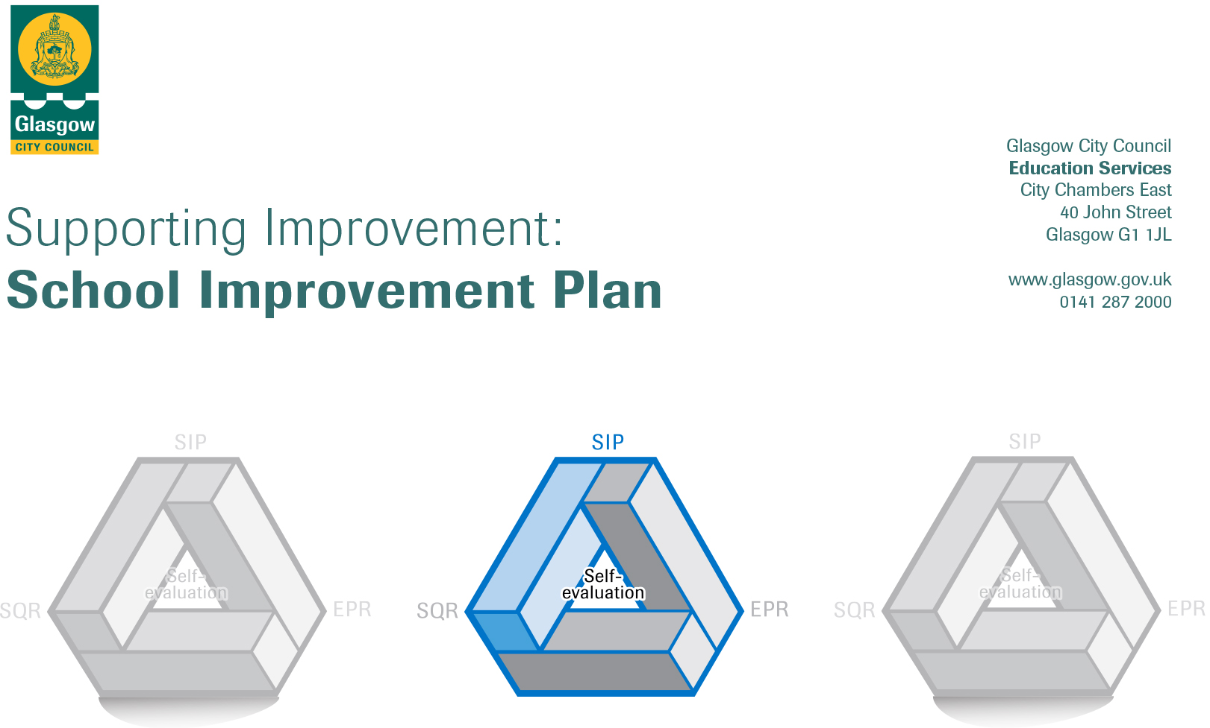

Session: 2019-20

Establishment |  | Burnbrae Childrens Centre
Head of Establishment |  | Janis Maguire
Area/Local Improvement Group |  | South LIG 1
Head of Service |  | Maureen McKenna
Area Education Officer/  Quality Improvement Officer |  | Donna Baillie

CONTENTS
1. Vision, Values and Aims
2. Summary of Self-Evaluation Process / Priorities for Improvement in the current session
3. Action Planning

Action Plan Summary for Stakeholders

1. Our Vision, Values and Aims
Our vision is to work closely with our families to build positive respectful partnerships which will enrich learning both at home, in nursery and in our community.
We will foster and develop an inclusive approach ensuring that children are aware of their rights as individuals, in a nurturing environment which encourages exploration, creativity and fun to aspire them to be the best they can be.

Burnbrae – in our community
Unique- every child will be treated as an individual
Respected – children will be listened to and know who to speak to if they need support
Nurture – to provide a safe and secure environment
Building – trust through communicating in an open and honest way
Resilient – Up for a challenge, - Never give up!
Achieving – children will experience exciting active learning both indoors and out.
Equality – everyone will have active involvement in all areas of the nursery and the community

2. Summary of our self-evaluation process.
Our Self Evaluation is driven by How Good Is Our Early Learning and Child Care (HGIOELC) and a monitoring calendar is used for systematic evaluation, we work alongside Educational Psychologist with regards to additional support for learning which supports staff in the implementation of Getting it Right for Every Child
We take account of Glasgow City Council local outcomes and keep abreast of Education Scotland and Scottish Government initiatives.

We gathered evidence from:
- Weekly room meetings ensured that there was opportunity for staff discussion (pre 1140hrs)
- Staff have annual PDP and mentoring throughout the year ensuring that we were on track to support staff skills to further develop their knowledge.
- Questionnaires and ‘post its’ to answer question on white board at main entrance are used with Parents/carers
- Staff In-Service Training
- HGIOELC quality indicators
- Monitoring and playroom observations

Strengths identified:

- LPA role with the focus on Literacy has up skilled some staff and had impact on children’s language skills
- One staff member has completed Glasgow Counts Training and has impacted on numeracy within the playroom
- Home visiting programme has been very successful in building relationships with families and easing Home nursery transitions
- Collaborative work with LC has resulted in enhanced peer relationships, moderation and assessment and networking opportunities
- Digital Learning Strategy poster created with LC nurseries
- Two staff members are currently undertaking BA IN Childhood Practice
- Promoted family learning with ‘Wee Play’, PATHS,STEM home link bags, and parents joining us on trips

Priorities for development:

1: Ensuring Well-being , equality and inclusion

2: Developing Creativity and skills for learning and life

3: Effective use of Assessment

No. | Quality Indicator | Priority
1 | 3.1 | Ensuring Well-being , equality and inclusion

Tasks to achieve priority | Timescale  and checkpoints | Evidence of Impact > (data, observation, views)
Revisit our nursery values with staff, children & parents | Term 1,2,3,4 | In service training ,for all staff, parents workshop,questionaires- parents staff & children. Values embedded in our practice
Staff Induction new staff /Checklists – all staff | Term1 &3 | Checklists for all staff, staff support sessions, childrens learning opportunities
Well being of practitioners | Term 1,2,3,4 | PDP’s, Peer support buddies, training opportunities, reflective question checklist, moderation checklist , room meetings, coaching sessions
Gender Friendly Accreditation | Term 1,2,3,4 | Parents info session, staff training, environment

Staff leading on this priority – including partners | Resources and staff development
Kim, Mairi – Gender friendly  Learning community nurseries  Parents  SMT | Equipment/resources  Arrange visits to other establishments  Professional dialogue sessions.  Training

No. | Quality Indicator | Priority
2 | 3.3 | Developing Creativity and skills for learning and life

Tasks to achieve priority | Timescale  and checkpoints | Evidence of Impact > (data, observation, views)
Inservice ‘What is creativity?’ | August 2019 | All staff will have an awareness of creativity
Playroom Organisation /Environment’s | Term1,2 | Scanning & Scoping exercise , collaboration, partnership working
Tapestry – training for Teacher Learning communities | On-going thru term 1,2,3,4 | Raising attainment through staff understanding the importance of reflecting and embedding measures into everyday practice
Digital learning to enhance teaching & learning | Term 2 ,4 | Profiles, learning conversations, parents input

Staff leading on this priority – including partners | Resources and staff development
Tsk 1, 2 - Amy & Kim  Task 3 – Tapestry  Task 4 – all staff & Learning community ,DL champion | WIFI  Professional dialogue  Training

No. | Quality Indicator | Priority
3 | 2.3 | Effective use of assessment
Tasks to achieve priority |  |  | Timescale and checkpoints | Evidence of Impact > (data, observation, views)
Planning process |  |  | Term 1,2 | Environment poster, reflective account of zone including skills & dev
Moderation & assessment ; collaborative working with Hill park LC |  |  | Term 1, 2, 3 4 | Increase in confidence in practitioner judgements – practitioners questionnaires, assessment information will be better, more consistent expectations of learning & understanding with and beyond
Partnership with parents |  |  | Term 1 , 3 | Learning journal input from parents, parents meetings, dialogue, seesaw (wifi dependant)

Staff leading on this priority – including partners | Resources and staff development
All staff  LC  Digital Learning Champion  Parents | Equipment  Wifi  Visits to other establishments  Professional Dialogue  Training

