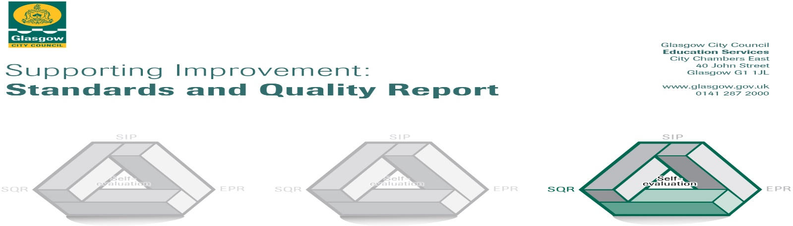

The summary report is provided for parents/careers and partners to outline our achievements this session and our priorities for next session. Throughout this session we have taken forward our priorities as detailed in our school improvement plan. Through our processes of self-evaluation, we have identified how we can improve outcomes for our children and young people.

Our achievements and improvements this year.
We would like to highlight the following improvements/achievements:
- Digital Learning was a big focus for us this year with lots of opportunities for staff to work with staff from other Learning Community Nurseries to develop staff digital skills and create our Digital Learning Strategy – which is displayed in our corridor.
- Almost all staff now have an ipad which they use with the children to record learning conversations and share learning on our new Facebook page which is monitored and private with only parents of children at Burnbrae being members
- Learning Community Nurseries, Primary and Secondary children & young people joined together to have a STEM Showcase to share learning.
- Some children within 3-5 room took part in the ‘We are Engineers’ project were they identified a problem and designed methods to fix it. This ran for 10 weeks and resulted in 1 x a distinction, 1X highly commended and 8 x merit awards. Out of 17500 entries from nurseries ,primaries and secondary schools we did a fantastic job
- We celebrated national book day with a Book Bug session and all 3 years old were presented with their Book Bug Treasure bag ,we also had weekly Book Bug sessions for our children under 3
- A home visiting program was devised and proved very popular with families and helped children settle into nursery life with very little upset. We used the Transition Teddy Bags to help with this process and this year children will keep the teddy from their bag.
- Our LPA (Lead Practitioner of Attainment) secured funding and created a quiet comfy space in our corridor to be used by parents and small groups of children.
- The LPA had extensive training on Literacy which resulted in all staff having refresher PATHS Training and Phonological Awareness Training. This resulted in children having opportunity to be more creative with stories, rhymes, and language.
- Home link bag program was used extensively by all children and evaluations were positive
- One staff member attended Glasgow Counts Training and a number table in the main corridor was used very well by parents and children at drop off /collection times. The whiteboard proved to be big successes with all children mark making and some even writing the number of the week.
- We ran 2 blocks of Wee Play where children and parents had opportunities to develop their physical literacy. This was attended by 18 families.
- Through consultation with our parents/ carers we ran Parents Night at times to suit individual families resulting in an 80% turn out. Families unable to attend were given written reports.
- December we had a Family Trip to see the lights at George Square which was of no cost to the families as we managed to secure funding for the buses. This was attended by 75 families, with siblings, grandparents, and aunties joining the fun.
- This year we made new friends, we worked closely with the residents of Silverburn & Darnley Care Homes. We built lovely relationships with the residents and visited regularly taking gifts such as drawings and home baking. And we were finalists of the Evening Times Streets Ahead Award for all our hard work.
- Sports Day was a great success with all most all families attending and taking part.
- We managed to raise £57 For Macmillan with a coffee morning /afternoon, parents baked and joined us on the day for some fun games and chat.
- This year we asked parent to join us on our outings to the Science Centre and to see Dippy the Dinosaur. This again was a great success with parents and children learning together.
- We got all our families active on a Saturday with our Mile Walk on a lovely September morning, 24 families attended along with staff and everyone had great fun, this is something we will repeat this year ahead
- Policy review group, which included parents staff and students met twice a year to review and reflect on practice.
- 2 Staff members completed their 2 nd year of their BA in Childhood Studies Degree.

Here is what we plan to improve next year.
1: Ensuring Well-being , equality and inclusion
2: Developing Creativity and skills for learning and life
3: Effective use of Assessment

How can you find out more information about our school?
Please contact us directly if you require further information or if you wish to comment on the report.

The contact e-mail address is:jmaguire@burnbrae-nursery.glasgow.sch.uk

Our telephone number is:0141 881 0923

Our school address is:271 Househillmuir Road G53 6nl

Further information is available in: newsletters, the school website, and the school handbook

